**Revroll Database.**

**Entity Relationship Diagram (ERD)**

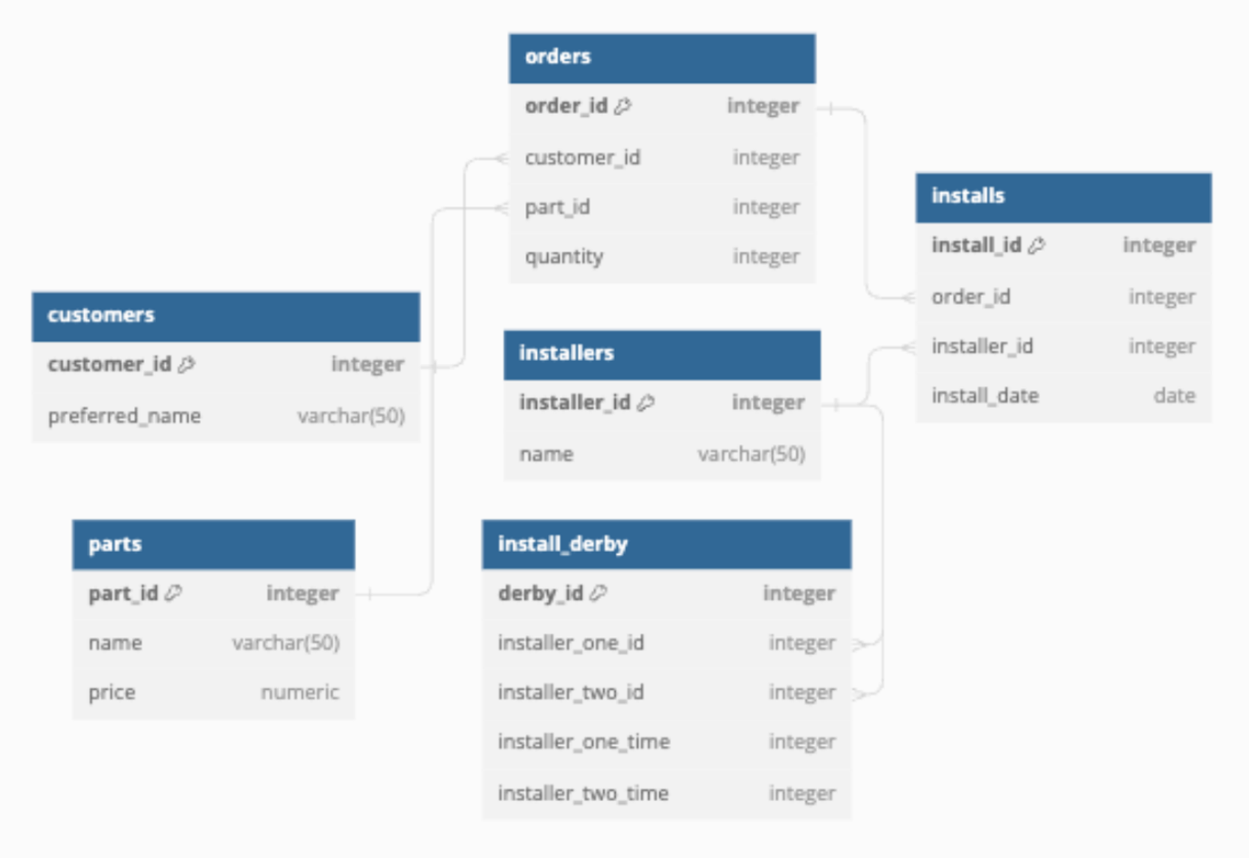

**Data Dictionary**

* **customers**: customer details
  + **customer_id**: unique customer ID (key, integer)
  + **preferred_name**: name preferred by the customer (varchar(50))
* **installers**: information about installers
  + **installer_id**: unique installer ID (key, integer)
  + **name**: name of the installer (varchar(50))
* **installs**: records of installations
  + **install_id**: unique install ID (key, integer)
  + **order_id**: ID of the order (integer)
  + **installer_id**: ID of the installer (integer)
  + **install_date**: date of installation (date)
* **orders**: details of customer orders
  + **order_id**: unique order ID (key, integer)
  + **customer_id**: ID of the customer (integer)
  + **part_id**: ID of the part ordered (integer)
  + **quantity**: number of parts ordered (integer)
* **parts**: information about parts
  + **part_id**: unique part ID (key, integer)
  + **name**: name of the part (varchar(50))
  + **price**: price of the part (numeric)
* **install_derby**: records of installer competitions
  + **derby_id**: unique derby ID (key, integer)
  + **installer_one_id**: ID of the first installer (integer)
  + **installer_two_id**: ID of the second installer (integer)
  + **installer_one_time**: time taken by the first installer (integer)
  + **installer_two_time**: time taken by the second installer (integer)